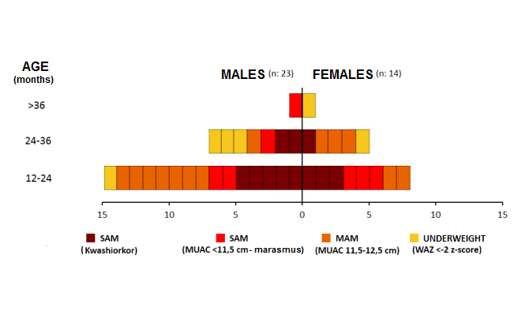
Figure 1. Classification of malnutrition by age and sex at baseline

